[재범률 통계](http://kosis.kr/statHtml/statHtml.do?orgId=132&tblId=DT_13204_6506&vw_cd=MT_ZTITLE&list_id=132_13204_GKIT659_duw251_CE451&scrId=&seqNo=&lang_mode=ko&obj_var_id=&itm_id=&conn_path=K1&path=%25EB%25B2%2594%25EC%25A3%2584%25E3%2586%258D%25EC%2595%2588%25EC%25A0%2584%2520%253E%2520%25EA%25B2%25BD%25EC%25B0%25B0%25EC%25B2%25AD%25EB%25B2%2594%25EC%25A3%2584%25ED%2586%25B5%25EA%25B3%2584%2520%253E%25202011%25EB%2585%2584%2520%25EC%259D%25B4%25ED%259B%2584%2520%253E%2520%25EB%25B2%2594%25EC%25A3%2584%25EC%259E%2590%2520%25EC%259C%25A0%25ED%2598%2595%2520%253E%2520%25EC%25A0%2584%25EA%25B3%25BC%25EB%25B2%2594%25EC%25A3%2584%25EC%259E%2590%25EC%25A0%2584%25EA%25B3%25BC%25EB%25B2%2594%25EC%25A3%2584%25EC%259E%2590%2520%25EC%259E%25AC%25EB%25B2%2594%25EC%25A2%2585%25EB%25A5%2598%2520%25EB%25B0%258F%2520%25EA%25B8%25B0%25EA%25B0%2584)  << 링크

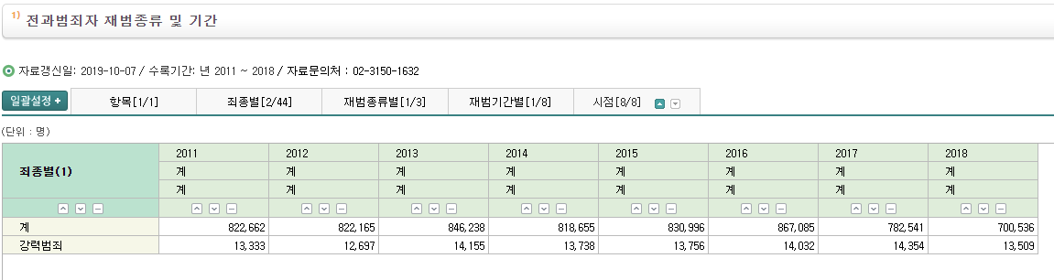

2차피해의 가능성

(<https://www.opengirok.or.kr/4420>)

피의자의 가족, 지인이라는 이유로 범죄와 무관한 무고한 주변인들이 개인정보 유출의 피해와 낙인효과로 고통받는 2차 피해가 발생할 수 있음

<http://www.donga.com/news/article/all/20131203/59291716/1>